Garden Tidy

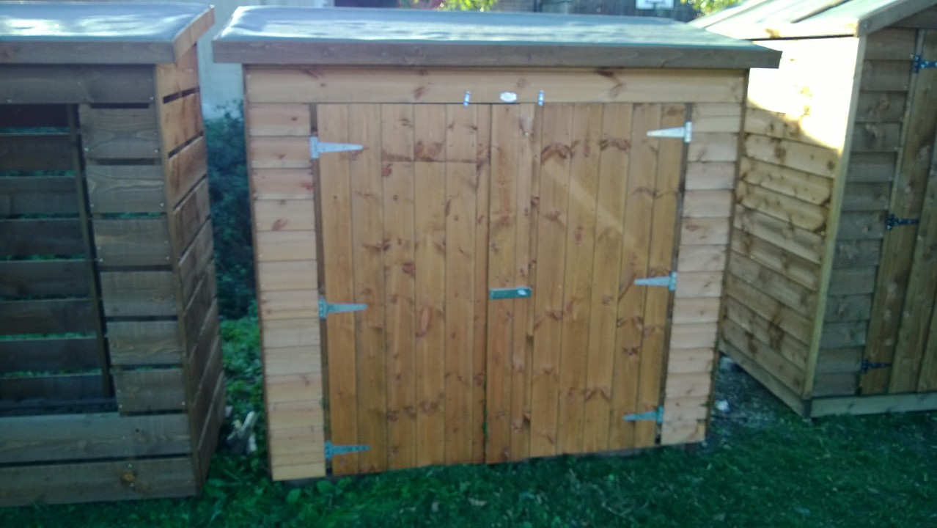

Size | Price | Treatment | Erect
2’6”D X 5’W X 5’10”H | £260 | £8 | £26
3’D X 6’W X 5’10” H | £294 | £8 | £26

Other sizes available on request

All prices plus V.A.T

Delivery to your area £

